Toward Self-Sensing Roads: A Systematic Review of Embedded IoT Sensors for Pavement Monitoring and Maintenance
Maryam Nasir Suleman
Department of Computer Science
University of Engineering and Technology
Lahore, Pakistan
ORICD ID: 0009-0005-6926-8341

Abstract—
Keywords—

Introduction
Civil infrastructure—including bridges, buildings, water pipelines, offshore platforms, and oil storage tanks—operates in dynamic, harsh environments characterized by large temperature fluctuations and elevated CO₂, which accelerate material degradation over time [1], [2], [3]. Consequences include crack initiation, crevice formation, and a gradual loss of structural capacity. Early localization and sizing of defects are therefore critical to avoid catastrophic failures. Yet periodic visual inspections and manual assessments are inherently limited in detecting incipient damage, and most conventional destructive and non-destructive techniques do not provide continuous condition data, underscoring the need for advanced monitoring approaches that leverage smart, sensor-enabled materials [4].
Smart technologies—IoT, pervasive sensorization, and AI—are reshaping pavement data collection and analysis, enabling smarter, more efficient asset management aligned with UN sustainability goals [5]. By delivering continuous, high-quality real-time streams, smart pavements improve Pavement Management Systems (PMS) and support faster, evidence-based decisions [6]. Central to this shift are pavement-embedded smart sensors that convert passive roads into responsive infrastructure by sensing, analyzing, and transmitting traffic, environmental, and structural-health data in real time.
Systematic pavement monitoring is essential for collecting reliable data and insights for performance assessment and analytics [7]. Conventional “auscultation” campaigns usually rely on visual inspections and specialized survey vehicles to measure bearing capacity and surface condition. However, these methods are labor-intensive, time-consuming, expensive, and often unable to capture early-stage micro-damage or its progression. These limitations have motivated intensive research over recent decades into advanced sensing technologies and non-destructive testing (NDT) methods that can monitor traffic loads and pavement health more effectively, ideally providing continuous or real-time information [7], [8].
Embedded sensors in asphalt pavements make it possible to continuously measure stress, strain, and deflection, providing the data needed for modern PMS and real-time decision support tools, including Digital Twins [9]. Traditional devices—such as strain gauges, LVDTs, accelerometers, load cells, geophones, and thermocouples—have recently been complemented by wireless sensor networks and fiber-optic technologies, which have shown strong potential in field applications [8], [10]. Their feasibility has been demonstrated on several full-scale facilities, including the NCAT test track, the Virginia Smart Road, MnRoad, and the PEGASE platform [11]. However, these intrusive sensors face important durability challenges: they must survive high temperatures and stresses during construction, then endure heavy traffic and harsh environmental conditions throughout service life, and any mismatch between the sensor and asphalt mixture can create mechanical discontinuities that may contribute to premature pavement failure [12].
Smart pavement sensing spans three complementary tiers. (1) Smart composites—e.g., piezoresistive or conductive mixes embedded in the matrix—add self-sensing (and potentially self-healing) capabilities that extend service life and cut maintenance and rehabilitation needs [13]. (2) Surface-mounted sensors—such as microphones and other recorders—capture vibrations, noise, and temperature for rapid condition checks and are easy to install and maintain for continuous monitoring [14]. (3) In-pavement sensors—including fiber-optic strain/temperature sensing and stress gauges—measure internal responses (strain, moisture, subsurface damage) to enable early failure detection and to assess materials/designs under real loads over time [15].
In situ sensing for pavements has become a major focus in road engineering because it enables structural health monitoring (SHM)—the real-time tracking of internal deformation and damage in civil infrastructure . Active SHM systems use sensors, data acquisition and communication units, and diagnostic/decision modules to detect defects and monitor strain, temperature, and other indicators in real time, supporting timely and effective maintenance decisions, as shown in Fig. 1.
Although several reviews address smart data collection and analytics for pavements [6], [16], a targeted synthesis of state-of-the-art embedded smart technologies is still needed. This paper fills that gap by surveying embedded sensor systems—their underlying technologies, applications, and anticipated impacts on pavement management—while detailing technical nuances, practical challenges, and future research directions. We emphasize integration with pavement management systems (PMS) and outline a clear roadmap for adopting embedded sensing in practice to enable more resilient, intelligent, and sustainable road infrastructure.
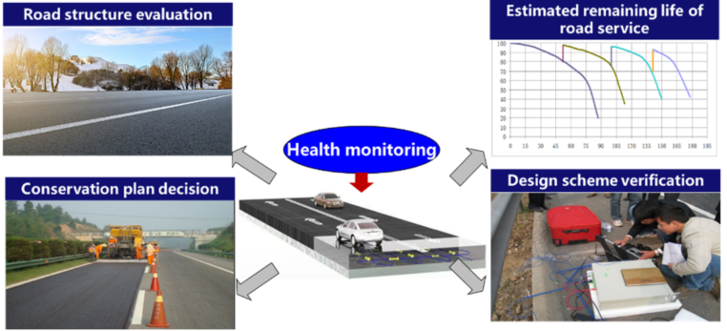
Fig. 1: Pavement health monitoring

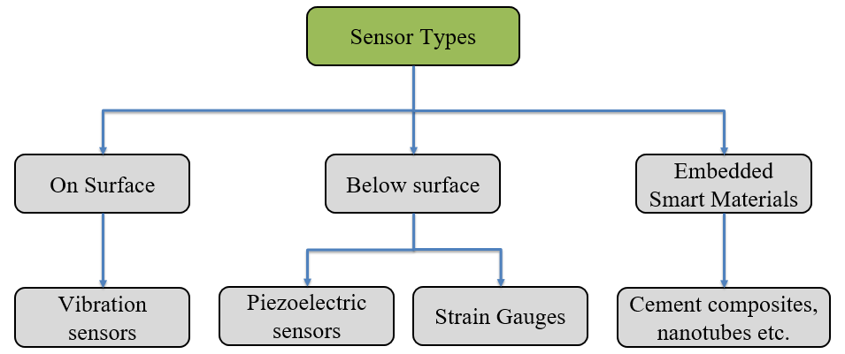
Fig. 2: Pavement sensing types

Related Work

Weigh-In-Motion Sensing
Birgin et al. highlight the need for cost-effective Weigh-In-Motion (WIM) solutions in smart pavements, especially for bridge condition monitoring. They propose a WIM algorithm that leverages conductive cementitious materials, inferring axle passages from resistance changes to estimate axle loads and classify vehicles. Numerical simulations validate the method across multiple truck types and show robust accuracy even with noise levels up to 5% of the signal peak [17].

Graphite-Enhanced Cement-Based Composite Sensing
Birgin et al. developed a low-cost, scalable graphite-enhanced cement-based composite for Weigh-In-Motion (WIM) sensing, indicating strong potential for practical traffic-monitoring deployments [18]. In related work, they introduced an eco-friendly synthetic binder (EVIzero) with carbon-microfiber inclusions that imparts piezoresistive behavior, enabling strain sensing and vehicle-load detection without disrupting traffic. The composite was reported to be cost-effective, durable, straightforward to implement, and precise, with a tailored electrode layout that reduces the number of required sensors [19].

Cement-Based Sensor Using Rubber Fibres
Smart materials extend beyond flexible pavements. Dong et al. developed a cement-based sensor using layer-distributed conductive rubber fibers to enhance structural health monitoring. They examined constituents, fabrication, electrical behavior, self-sensing efficiency, repeatability, and compressive strength, finding that the fibers markedly improved conductivity. The resulting rubber-fiber cementitious composites show strong potential for concrete SHM and pavement traffic monitoring, offering intrinsic sensing, durability, and minimal impact on mechanical performance [13].

Nano-Material Sensing
Multiple studies investigate Carbon Nanotubes (CNTs), Graphene Nanoplatelets (GNPs), and CNT–GNP hybrids for both rigid and flexible pavements. Xin et al. evaluated CNT/epoxy composites, showing promising strain-sensor performance for asphalt monitoring: CNTs increased tensile strength and elastic modulus, though excessive loading caused agglomeration and degraded mechanics. In follow-up work, they dispersed three CNT types (varying specific surface area) and GNPs in epoxy, finding that CNT–GNP hybrids formed superior conductive networks and dispersed more uniformly than CNTs alone, enhancing electrical response and strain-sensing. Laboratory validation—including three-point bending on asphalt beams with embedded sensors—confirmed durability and high measurement accuracy [20], [21].

Self-Sensing Asphalt Mixtures
Gulisano et al. developed and evaluated self-sensing asphalt mixtures incorporating coarse aggregates, fine electric-arc-furnace slag (EAFS), polymer-modified bitumen, and graphene nanoplatelets (GNPs). Electromechanical tests showed a linear relation between applied stress and electrical response, and wavelet-transform analysis indicated robust long-term and damage-sensing performance—supporting real-time pavement health monitoring [22]. Ozbulut et al. produced GNP-reinforced mortars (Portland cement with ASTM-graded sand), observing that GNP contents >5% significantly reduced electrical resistivity, with 7.5% yielding optimal self-sensing behavior; these composites are strong candidates for continuous structural health monitoring [23].

Table 1: List of investigated literature works for smart materials
Smart Material Type | Application | Ref.
Graphite-Enhanced Cement Composites | Weight in motion sensing | [19]
Conductive Rubber Fiber Cement | Traffic monitoring | [19]
Carbon Nanotube (CNT) | Structural Health Monitoring (SHM) | [24]
CNT-GNP Hybrid Composites | Strain monitoring in asphalt | [24]
CNT-Cement Composites | Improved electrical conductivity | [24]
CNT Concrete Sensors | Piezoresistivity under fatigue, water, temp effects | [25]
GNP-Reinforced Mortar | Vehicle detection under real traffic | [25]
Bitumen with Magnetic Particles | Stress and damage sensing | [24]
CNTs & Graphene as Microwave Absorbers | Real-time SHM, reduced resistivity | [24]
Conductive Fibers + Electromagnetic Heating | Temperature-adaptive pavements | [19]
Photocatalytic Agent (OXE-CHI) | Enhanced asphalt healing via microwave | [25]
Microcapsules with Rejuvenator | Deep crack healing | [19]
Microvascular Structures with Oil-Based Rejuvenator | UV-based self-healing asphalt | [19]

Self-Sensing Mechanism and Assessment

Self-Sensing Asphalt Mixtures
Recent studies show that conductive asphalt mixtures can act as effective self-sensing materials, where changes in stress or strain are captured through variations in electrical resistance. Wu et al. [26] linked these resistance changes to proximity effects between conductive particles, microcrack formation, and disruption of conductive paths caused by aggregate motion. Liu et al. reported that graphite–carbon fiber mixtures can reach high gauge factors (GF =11 at 1.5 MPa and up to 350 at 0.7 MPa), highlighting their strong strain-sensing potential [27]. Other works demonstrated reliable sensing responses under different loading modes for mixtures with carbon nanofibers, as well as for asphalt containing EAF steel slag and graphene nanoplatelets. For weigh-in-motion and traffic monitoring, however, sensitivity must remain stable over time: Liu et al. [28] showed that mixtures with very high graphite content lose GF over repeated loading cycles, whereas mixtures with lower graphite content maintain their sensitivity, suggesting that long-term performance depends on the mixture’s conductive network. Building on this, Gulisano et al. [29] combined piezoresistive carbon-fiber asphalt with digital signal processing and an artificial neural network, achieving a load-classification accuracy of 0.977 and demonstrating the promise of these materials for future smart pavement and WIM applications.

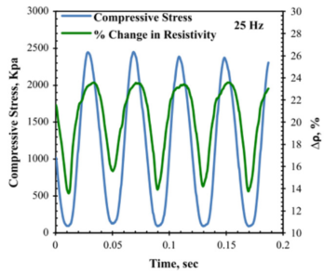
Fig. 3: Piezoresistive response of asphalt mixtures under various loading conditions. Adapted from [13].

Damage Sensing
Self-sensing asphalt materials can also act as “damage sensors,” because their electrical resistance changes as microcracks form and propagate within the mixture. Although this mechanism is distinct from classic strain-based piezoresistivity, it is crucial for early damage detection and continuous pavement health monitoring: as cracks cut conductive paths, electrical resistance generally increases, so tracking fractional change in resistance (FCR) over time can signal emerging distress and support preventive maintenance. Damage-sensing performance is typically evaluated in tests carried out to failure, and several studies have shown clear links between electrical response and structural degradation. Liu et al. [28] reported three characteristic FCR phases during fatigue loading of graphite–carbon fiber asphalt: initial compaction and reduced resistance, a quasi-stable phase with competing compaction and microcracking, and finally a sharp resistance increase as cracks dominate and the conductive network collapses. Similar multi-stage resistance trends and strong correlations between displacement, crack growth, and resistivity were observed under tensile and fatigue loading in graphite–carbon fiber mixtures and carbon fiber–graphite concretes [30]. Mixtures with carbon nanofibers, EAFS + graphene nanoplatelets, and carbon fiber with iron tailings have likewise shown robust damage-sensing behavior, with resistance evolution closely tracking crack formation and propagation. Advanced signal-processing methods, such as continuous wavelet transform and multiresolution analysis, further enhance the ability to interpret these electrical signals and identify cracking events [31]. However, fully exploiting this capability will require future development of statistical and predictive models that relate FCR to pavement structural condition so that electrical response can be used as a practical pavement condition index in real-time health monitoring systems.

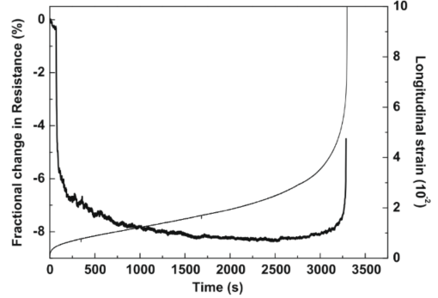
Fig. 4: Damage sensing during a compressive fatigue test, showing longitudinal strain (thin curve) and FCR (thick curve). Adapted from [22].

Temperature and Moisture Sensing
Conductive asphalt mixtures may also be able to sense temperature and moisture, offering a built-in alternative to conventional embedded devices such as thermocouples and thermistors for pavement temperature monitoring. If asphalt can be designed with reliable thermoresistive behavior—where electrical resistance changes predictably with temperature—it would not only remove the need for separate thermal sensors, but also allow correction of temperature effects when interpreting piezoresistive or damage-sensing signals; this behavior is typically described through the Temperature Coefficient of Resistance (TCR). Experimental results are mixed: Wu et al. [32] and Sun et al. [33] observed a Positive Temperature Coefficient (PTC) in conductive asphalt, where resistance increases with temperature, likely because bitumen expansion separates conductive particles. In contrast, studies on cementitious composites have reported Negative Temperature Coefficient (NTC) behavior, with resistance decreasing as temperature rises due to reduced tunneling distance and enhanced charge transport in the conductive network. Chen et al. [34] even found both PTC and NTC regimes in carbon-fiber-reinforced concrete depending on temperature range, underscoring that the thermoresistive behavior of conductive asphalt is still not fully understood and requires further research. Moisture is another critical factor, as it degrades asphalt–aggregate adhesion and can cause stripping and moisture-related damage; while Ground-Penetrating Radar (GPR) is currently used to infer moisture conditions in pavements, intrinsically moisture-sensing asphalt would enable continuous monitoring in service. Although moisture sensors based on nano-modified Portland cement have been developed [35], comparable moisture-sensing capabilities in asphalt mixtures have yet to be systematically investigated.

References

[1] T. U. Kim, H. V. Le, J. W. Park, S. K. Eock, Y. Jang, and D. J. Kim, “Development of a smart concrete block with an eccentric load sensing capacity,” Constr. Build. Mater., vol. 306, p. 124881, Nov. 2021, doi: 10.1016/j.conbuildmat.2021.124881.
[2] S. Y. Lee, H. V. Le, and D. J. Kim, “Self-stress sensing smart concrete containing fine steel slag aggregates and steel fibers under high compressive stress,” Constr. Build. Mater., vol. 220, pp. 149–160, Sept. 2019, doi: 10.1016/j.conbuildmat.2019.05.197.
[3] J. Min, S. Park, C.-B. Yun, C.-G. Lee, and C. Lee, “Impedance-based structural health monitoring incorporating neural network technique for identification of damage type and severity,” Eng. Struct., vol. 39, pp. 210–220, June 2012, doi: 10.1016/j.engstruct.2012.01.012.
[4] S. Taheri, “A review on five key sensors for monitoring of concrete structures,” Constr. Build. Mater., vol. 204, pp. 492–509, Apr. 2019, doi: 10.1016/j.conbuildmat.2019.01.172.
[5] S. Gupta et al., “Assessing whether artificial intelligence is an enabler or an inhibitor of sustainability at indicator level,” Transp. Eng., vol. 4, p. 100064, June 2021, doi: 10.1016/j.treng.2021.100064.
[6] M. Amândio, “Integration of Smart Pavement Data with Decision Support Systems: A Systematic Review”, doi: https://doi.org/10.3390/buildings11120579.
[7] G. M. Sang, L. Xu, and P. de Vrieze, “A Predictive Maintenance Model for Flexible Manufacturing in the Context of Industry 4.0,” Front. Big Data, vol. Volume 4-2021, 2021, doi: 10.3389/fdata.2021.663466.
[8] A. Di Graziano, V. Marchetta, and S. Cafiso, “Structural health monitoring of asphalt pavements using smart sensor networks: A comprehensive review,” J. Traffic Transp. Eng. Engl. Ed., vol. 7, no. 5, pp. 639–651, Oct. 2020, doi: 10.1016/j.jtte.2020.08.001.
[9] M. Manosalvas-Paredes, R. Roberts, M. Barriera, and K. Mantalovas, “Towards More Sustainable Pavement Management Practices Using Embedded Sensor Technologies,” Infrastructures, vol. 5, no. 1, 2020, doi: 10.3390/infrastructures5010004.
[10] R. Bajwa, E. Coleri, R. Rajagopal, P. Varaiya, and C. Flores, “Pavement performance assessment using a cost-effective wireless accelerometer system,” Comput.-Aided Civ. Infrastruct. Eng., vol. 35, no. 9, pp. 1009–1022, Sept. 2020, doi: 10.1111/mice.12544.
[11] A. L. Priest and D. H. Timm, “Dynamic Pavement Response Data Collection and Processing at the NCAT Test Track,” 2004. [Online]. Available: https://api.semanticscholar.org/CorpusID:107292640
[12] X. Chapeleau, J. Blanc, P. Hornych, J.-L. Gautier, and J. Carroget, “Assessment of cracks detection in pavement by a distributed fiber optic sensing technology,” J. Civ. Struct. Health Monit., vol. 7, no. 4, pp. 459–470, Sept. 2017, doi: 10.1007/s13349-017-0236-5.
[13] W. Dong, W. Li, K. Wang, Z. Luo, and D. Sheng, “Self-sensing capabilities of cement-based sensor with layer-distributed conductive rubber fibres,” Sens. Actuators Phys., vol. 301, p. 111763, Jan. 2020, doi: 10.1016/j.sna.2019.111763.
[14] H. Hasni, A. H. Alavi, K. Chatti, and N. Lajnef, “A self-powered surface sensing approach for detection of bottom-up cracking in asphalt concrete pavements: Theoretical/numerical modeling,” Constr. Build. Mater., vol. 144, pp. 728–746, July 2017, doi: 10.1016/j.conbuildmat.2017.03.197.
[15] A. H. Alavi, H. Hasni, N. Lajnef, and K. Chatti, “Continuous health monitoring of pavement systems using smart sensing technology,” Constr. Build. Mater., vol. 114, pp. 719–736, July 2016, doi: 10.1016/j.conbuildmat.2016.03.128.
[16] E. Ranyal, “Road condition monitoring using smart sensing and artificial intelligence: a review”, doi: https://doi.org/10.3390/ s22083044.
[17] H. B. Birgin, “A Weigh-in-Motion Characterization Algorithm for Smart Pavements Based on Conductive Cementitious Materials”.
[18] H. B. Birgin, “Smart graphite–cement composite for roadway-integrated weigh-in-motion sensing”, doi: https://doi.org/10.3390/s20164518.
[19] B. H. Borke, “Innovative carbon-doped composite pavements with sensing capability and low environmental impact for multifunctional infrastructures”, doi: 10.3390/jcs5070192.
[20] X. Xin et al., “Self-sensing behavior and mechanical properties of carbon nanotubes/epoxy resin composite for asphalt pavement strain monitoring,” Constr. Build. Mater., vol. 257, p. 119404, Oct. 2020, doi: 10.1016/j.conbuildmat.2020.119404.
[21] X. Xin, “Pavement Structure: Substitutability and Synergy Effects of Graphene Platelets With Carbon Nanotubes in Epoxy Composites”, doi: https://doi.org/10.3389/fmats.2022.824364.
[22] F. Gulisano et al., “Stress and damage-sensing capabilities of asphalt mixtures incorporating graphene nanoplatelets,” Sens. Actuators Phys., vol. 359, p. 114494, Sept. 2023, doi: 10.1016/j.sna.2023.114494.
[23] O. E. Ozbulut, “Exploring scalable fabrication of self-sensing cementitious composites with graphene nanoplatelets”, doi: 10.1088/1361-665X/aae623.
[24] W. Dong, W. Li, K. Wang, Z. Luo, and D. Sheng, “Self-sensing capabilities of cement-based sensor with layer-distributed conductive rubber fibres,” Sens. Actuators Phys., vol. 301, p. 111763, 2020, doi: https://doi.org/10.1016/j.sna.2019.111763.
[25] A. Dinesh, S. Indhumathi, and M. Pichumani, “Self-sensing cement composites for structural health monitoring: From know-how to do-how,” Autom. Constr., vol. 160, p. 105304, 2024, doi: https://doi.org/10.1016/j.autcon.2024.105304.
[26] S. P. Wu, L. T. Mo, and Z. H. Shui, “Piezoresistivity of Graphite Modified Asphalt-Based Composites,” in Composite Materials III, in Key Engineering Materials, vol. 249. Trans Tech Publications Ltd, Aug. 2003, pp. 391–396. doi: 10.4028/www.scientific.net/KEM.249.391.
[27] X. Liu, S. Wu, Q. Ye, J. Qiu, and B. Li, “Properties evaluation of asphalt-based composites with graphite and mine powders,” Constr. Build. Mater., vol. 22, no. 3, pp. 121–126, 2008, doi: https://doi.org/10.1016/j.conbuildmat.2006.10.004.
[28] X. Liu and S. Wu, “Research on the conductive asphalt concrete’s piezoresistivity effect and its mechanism,” Constr. Build. Mater., vol. 23, no. 8, pp. 2752–2756, 2009, doi: https://doi.org/10.1016/j.conbuildmat.2009.03.006.
[29] Federico Gulisano, Freddy Richard Apaza Apaza, Daniel Gálvez-Pérez, Rafael Jurado-Piña, Gustavo Boada-Parra, and Juan Gallego, “Non-destructive testing methods for road pavement health monitoring: electromechanical assessment of self-sensing asphalt materials,” presented at the Proc.SPIE, Oct. 2023, p. 127340R. doi: 10.1117/12.2680606.
[30] X. Liu and S. Wu, “Study on the graphite and carbon fiber modified asphalt concrete,” Constr. Build. Mater., vol. 25, no. 4, pp. 1807–1811, 2011, doi: https://doi.org/10.1016/j.conbuildmat.2010.11.082.
[31] F. Gulisano, T. Buasiri, F. R. A. Apaza, A. Cwirzen, and J. Gallego, “Piezoresistive behavior of electric arc furnace slag and graphene nanoplatelets asphalt mixtures for self-sensing pavements,” Autom. Constr., vol. 142, p. 104534, 2022, doi: https://doi.org/10.1016/j.autcon.2022.104534.
[32] Wu Shaopeng, Pan Pan, Chen Mingyu, and Zhang Yuan, “Analysis of Characteristics of Electrically Conductive Asphalt Concrete Prepared by Multiplex Conductive Materials,” J. Mater. Civ. Eng., vol. 25, no. 7, pp. 871–879, July 2013, doi: 10.1061/(ASCE)MT.1943-5533.0000565.
[33] W. Sun, X. Li, Q. Yang, and H. Zhang, “Resistivity-temperature characteristics of conductive asphalt concrete,” J. Wuhan Univ. Technol.-Mater Sci Ed, vol. 31, no. 2, pp. 367–371, Apr. 2016, doi: 10.1007/s11595-016-1377-9.
[34] C. Bing, W. Keru, and Y. Wu, “Characteristics of resistivity-temperature for carbon fiber reinforced concrete,” J. Wuhan Univ. Technol.-Mater Sci Ed, vol. 21, no. 1, pp. 121–124, Mar. 2006, doi: 10.1007/BF02861488.
[35] T. Buasiri, K. Habermehl-Cwirzen, L. Krzeminski, and A. Cwirzen, “Novel humidity sensors based on nanomodified Portland cement,” Sci. Rep., vol. 11, no. 1, p. 8189, Apr. 2021, doi: 10.1038/s41598-021-87563-7.

